Bahria University,

Karachi Campus



LAB EXPERIMENT NO.

**7**

LIST OF TASKS

|  |  |
| --- | --- |
| TASK NO | OBJECTIVE |
| 1 | Write a program to check whether the input taken from user is greater than 0 or not. If the input is greater than 0, Do logical left shift operation on the input else do logical right shift operation on input. |
| 2 | Write a program in MIPS assembly language that takes input from user and print whether the input is greater or less than 10 and also shift input left and right 4 bits. |
|  |
|  |  |
|  |  |
|  |  |
|  |  |
|  |  |

Submitted On:

Date: 15/12/2021

**Task 1: Write a program to check whether the input taken from user is greater than 0 or not. If the input is greater than 0, Do logical left shift operation on the input else do logical right shift operation on input.**

**Solution :**

.data

input: .asciiz "Enter any number : "

left: .asciiz "Shift Left Logical = "

right: .asciiz "Shift Right Logical = "

.text

.globl main

main:

li $v0,10

syscall

left_shift:

la $a0,left

li $v0,4

syscall

sll $a0,$t0,1

li $v0,1

syscall

li $v0,10

syscall

la $a0,input

li $v0,4

syscall

li $v0,5

syscall

move $t0,$v0

bgtz $t0,left_shift

la $a0,right

li $v0,4

syscall

srl $a0,$t0,2

li $v0,1

syscall

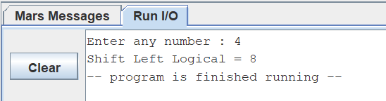**Output :**

.

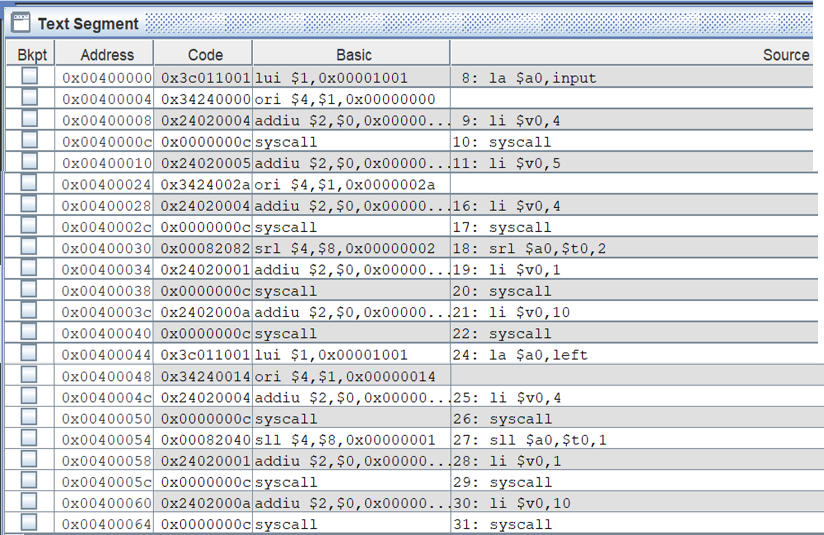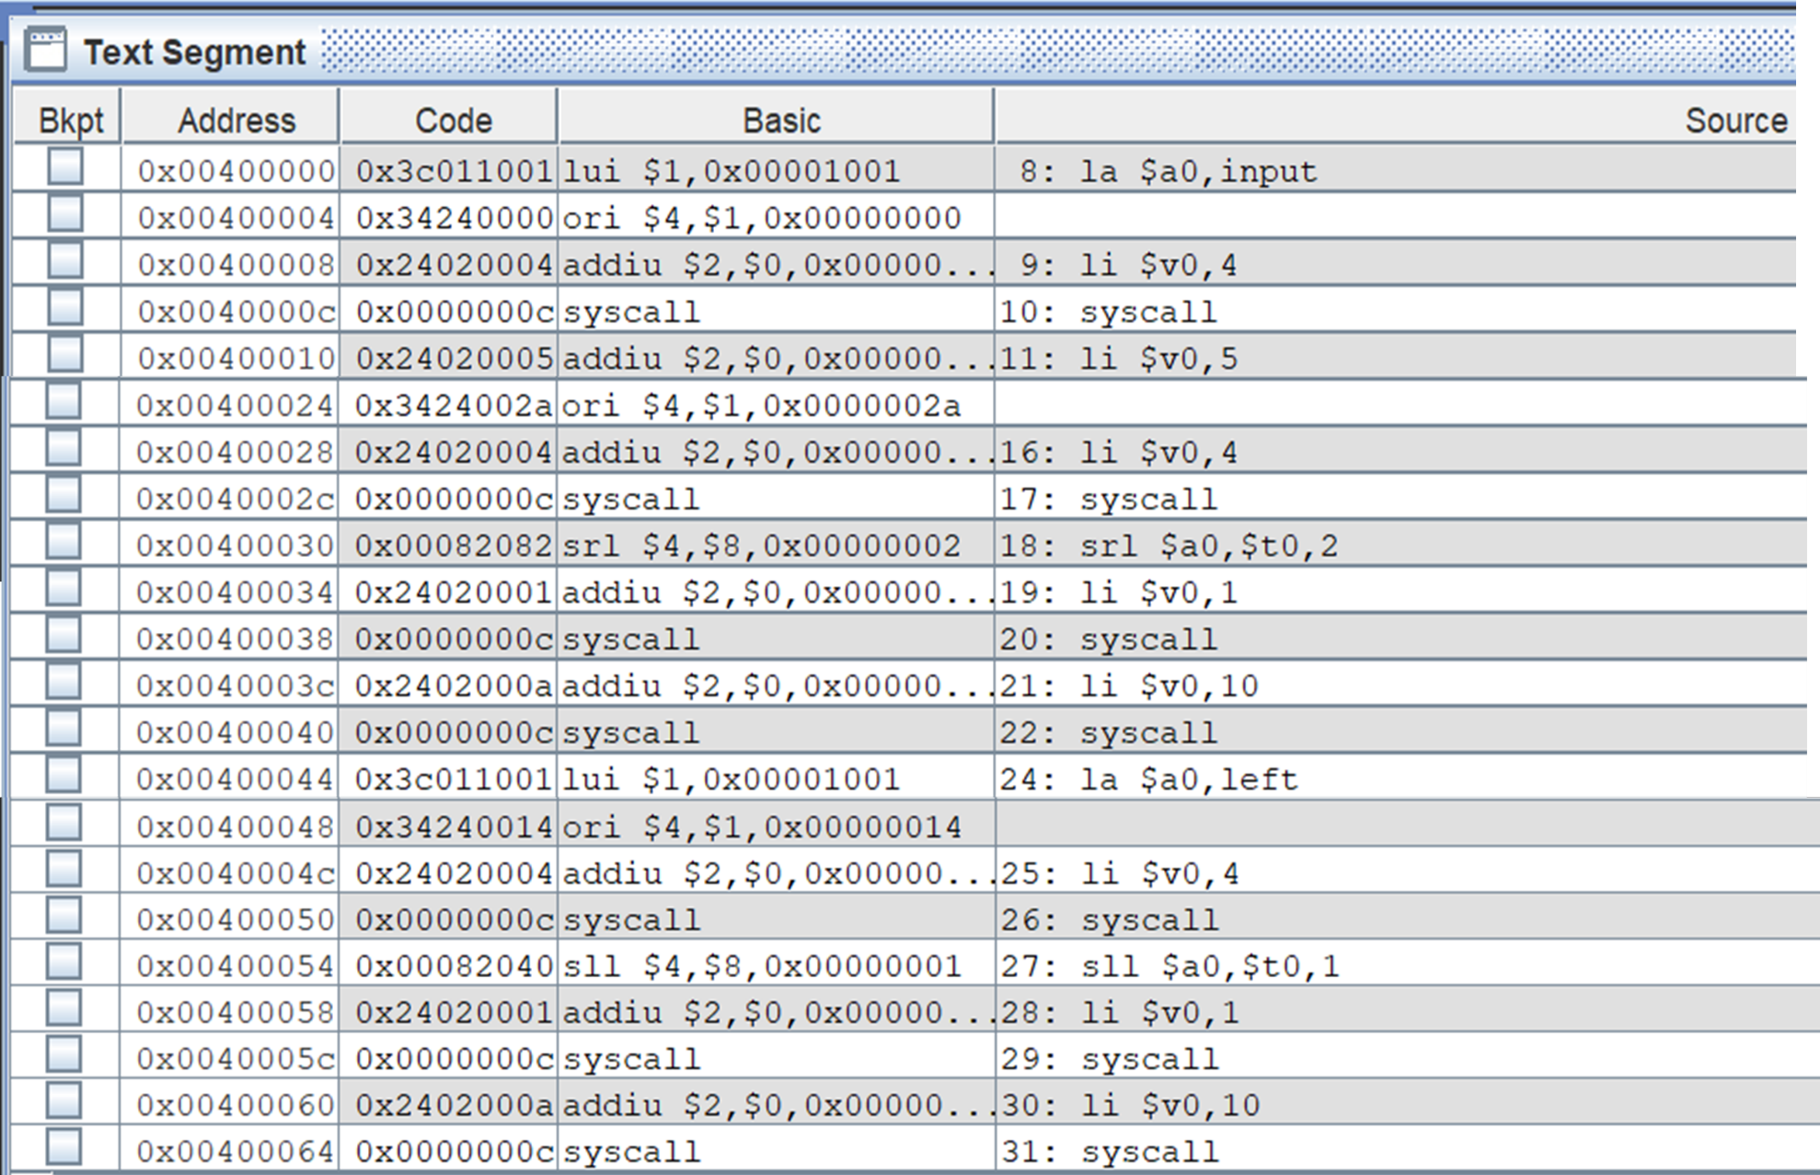

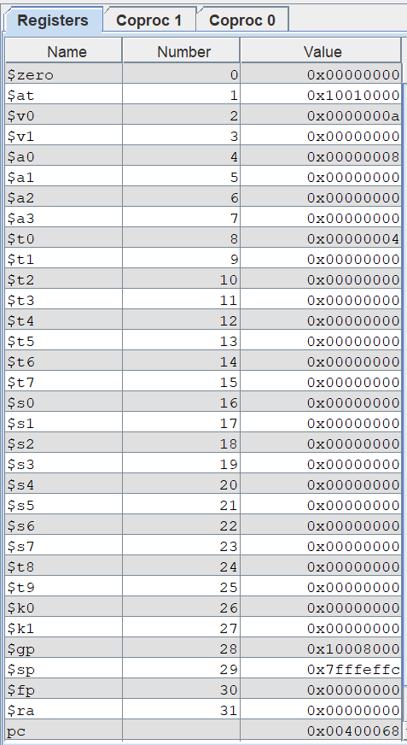

**Task 2 : Write a program in MIPS assembly language that takes input from user and print whether the input is greater or less than 10 and also shift input left and right 4 bits.**

**Solution :**

.data

input: .asciiz " Enter any Number = "

rshift: .asciiz "\n Number after 4 bits Right shift = "

lshift: .asciiz "\n Number after 4 bits Left shift = "

greater: .asciiz "\n====> Number is greater than 10 <====\n"

less: .asciiz "\n====> Number is less than 10 <====\n"

.text

.globl main

main:

shift:

la $a0,rshift

li $v0,4

syscall

srl $a0,$t0,4

li $v0,1

syscall

la $a0,lshift

li $v0,4

syscall

sll $a0,$t0,4

li $v0,1

syscall

b end

else:

la $a0,greater

li $v0,4

syscall

b shift

end:

li $v0,10

syscall

li $s0,10

la $a0,input

li $v0,4

syscall

li $v0,5 # read integer

syscall

move $t0,$v0

bgt $t0,$s0,else

la $a0,less

li $v0,4

syscall

b shift

**Output :**



